***ASSIGNMENT-1***

Q1. Find a student average mark given mark1 and mark2.

ALGORITHM:-

Step1: start

Step2: declare mark1, declare mark2 and average

Step3: read mark1 and mark2

Step4: add mark1 and mark2 and divide by 2

Mark1+mark2/2

Step5: assign result

Step6: display average

Step7: stop

FLOWCHART:-

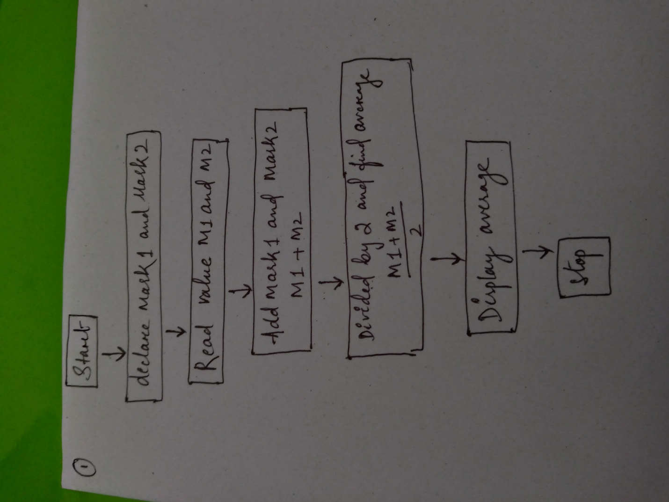

Q2.calculate the fine charged by library far late return books. The charge is 0.20 INR for 1 day.

ALGORITHM:-

Step1: start

Step2: declare final value, book price, late fee

Step3: read final value, book price

Step4: calculate book price with 1st day late fee

Step5: assign value to find value

Step6: calculate final value*0.1 till looped

Step7: stop

FLOWCHART:-

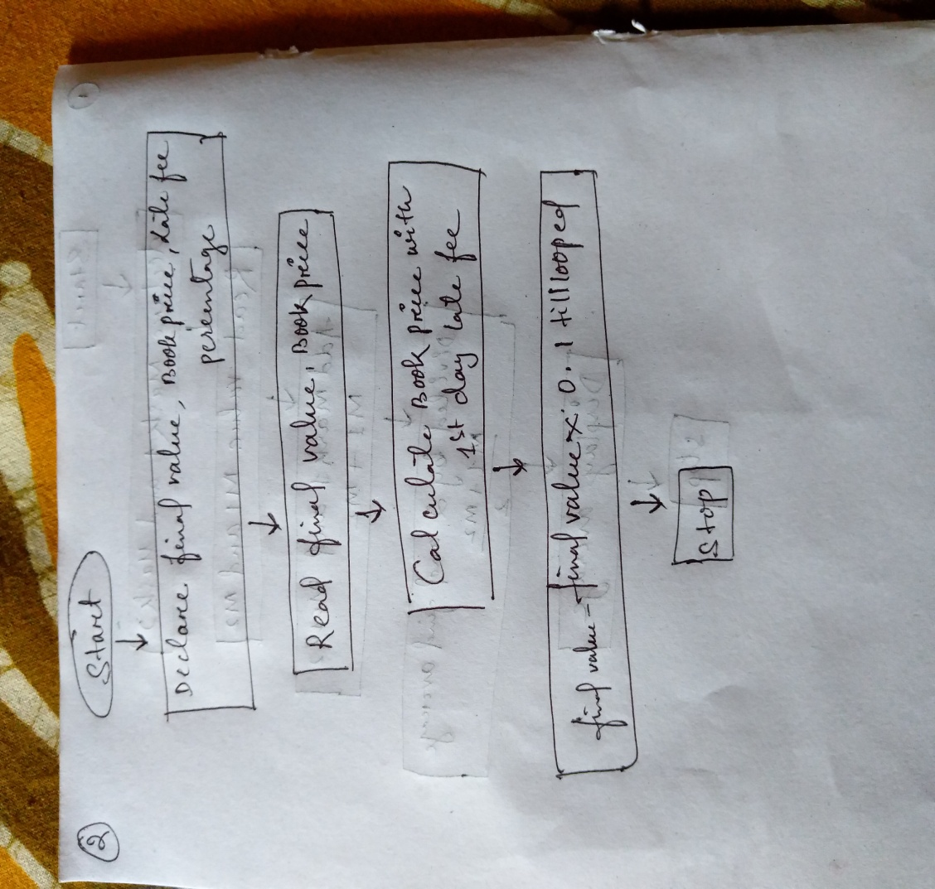

Q3. You had brought a nice shirt which cost rs.29.90 with 15% discount. Count the net price for the shirt.

ALGORITHM:-

Step1: start

Step2: declare cost, net price, discounted price, discount percentage,

Step3: discounted cost= discount*cost

Step4: net price= cost-discounted price

Step5: stop

FLOWCHART:-

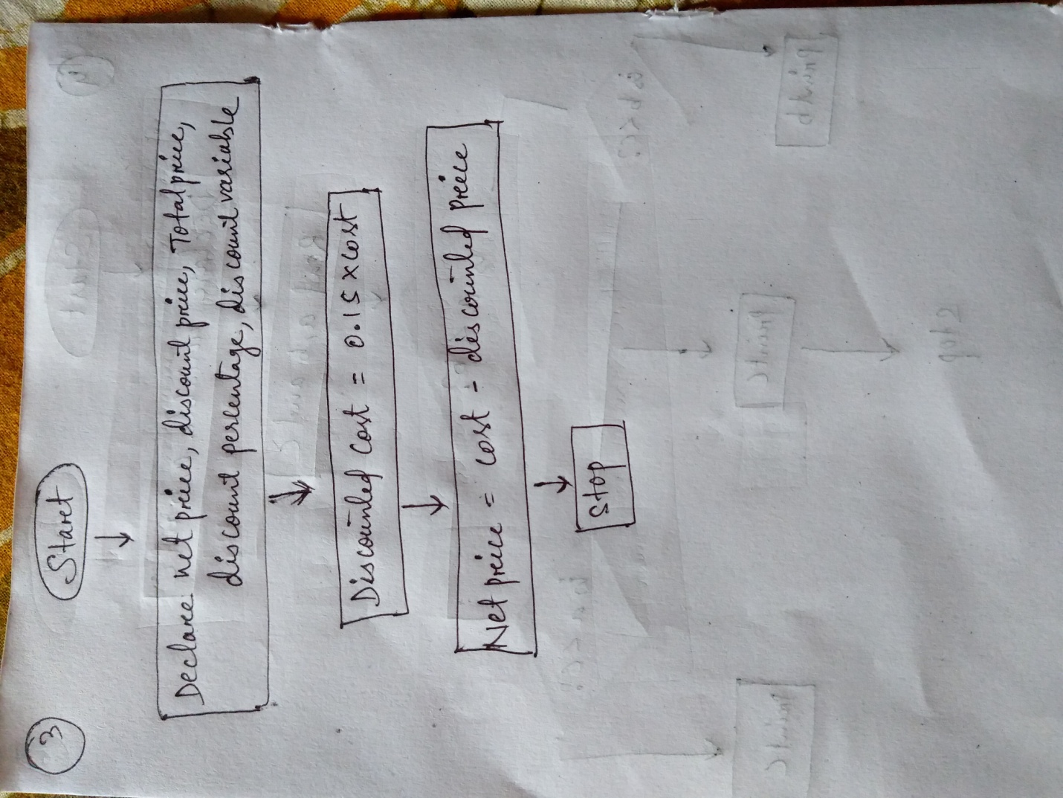

Q4. Find the smallest number among three different numbers.

ALGORITHM:-

Step1: start

Step2: declare variable a, b, c

Step3: read variable a, b, c

Step4: if a<b

If a>c

Display a is the smallest number

Else

Display c is the smallest number

Else

If b<c

Display b is the smallest number

Else

Display c is the smallest number

Step7: stop

FLOWCHART:-

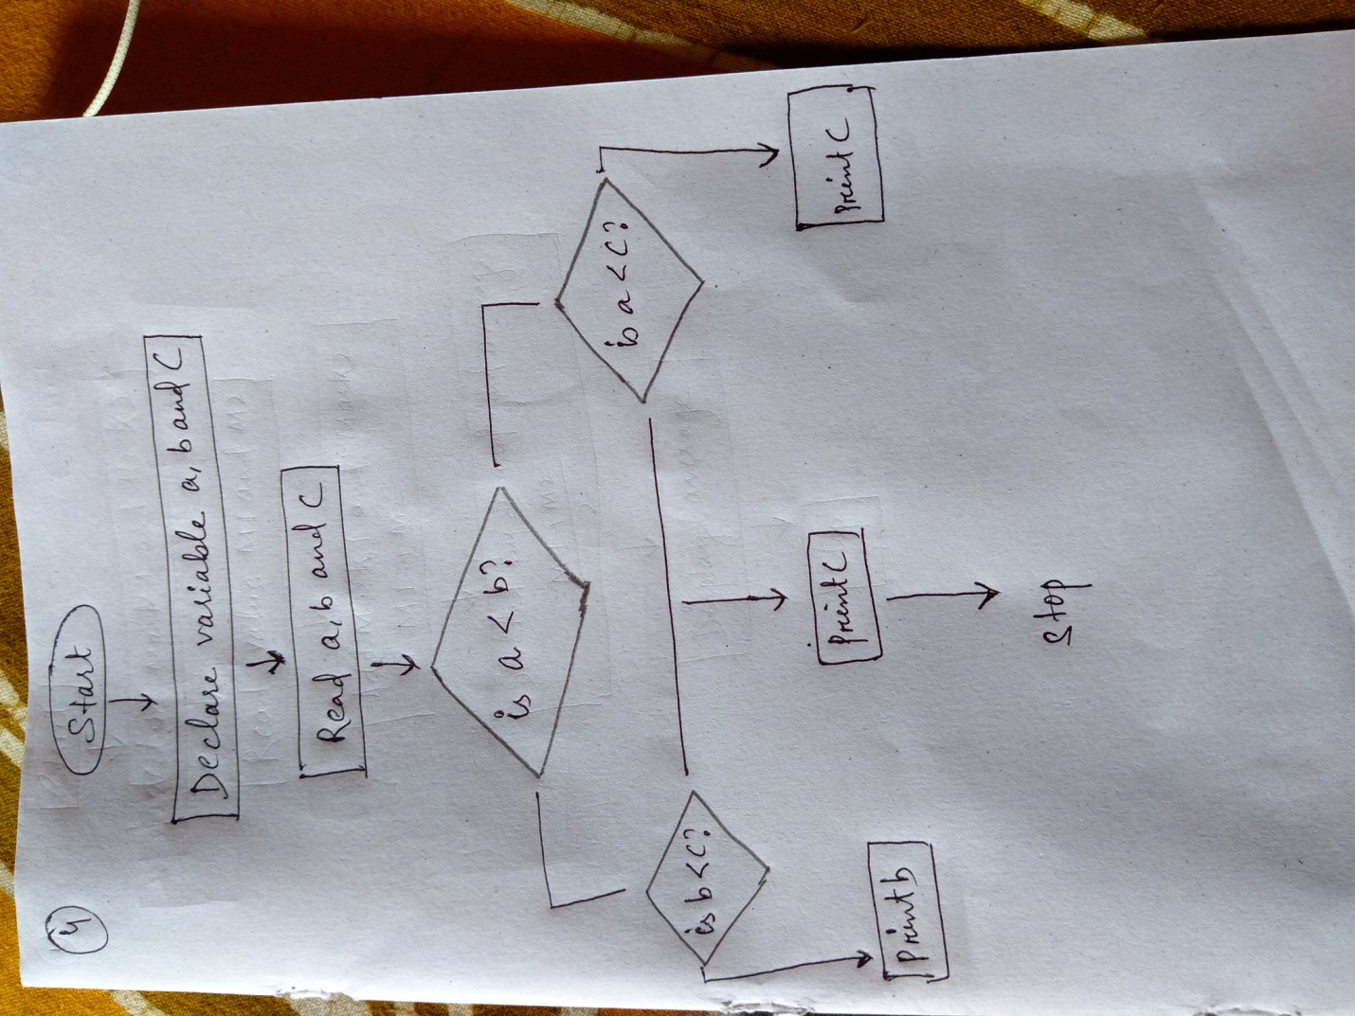

Q5.find the roots of quadratic equation ax2+bx+c=0

ALGORITHM:-

Step1: start

Step2: declare a, b, c

Step3: read the value a, b, c

Step4: s=b*b-4*a*c

Step5: if s>0

Display root will be real and unequal

S1=(-b+sqrt d/2)*a

S2=(-b-sqrt d/2)*a

Display s1 and s2

Else

If d=0

Else root will be imaginary

Step7: stop

FLOWCHART:-

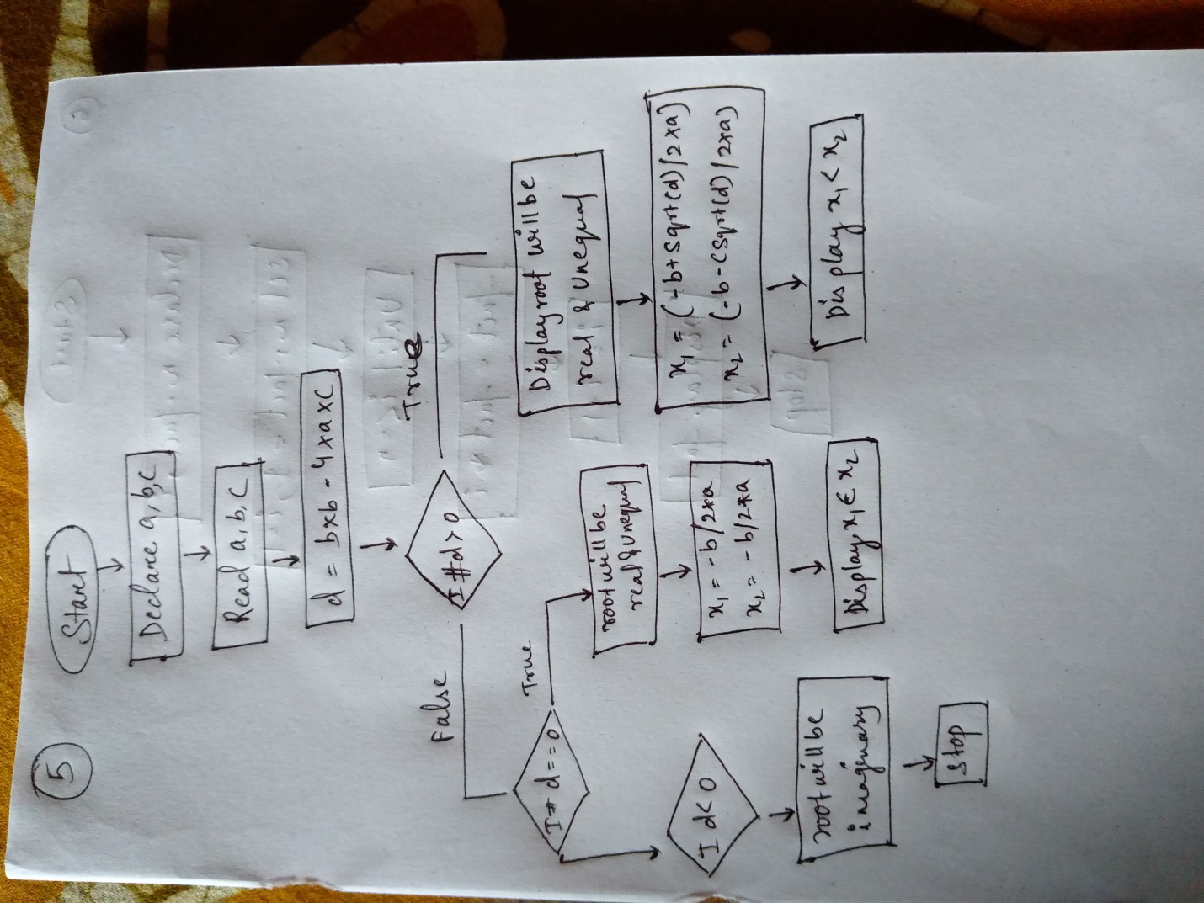

Q6.Find the factorial of a given number

ALGORITHM:-

Step1: start

Step2: declare the value of s fact=1,t=1

Step3: read the value of n

Step4: until (s<=n)

Step5: s=i+1

Step6: display fact

Step7: stop

FLOWCHART:-

